# 4 Page Four

Moist curry rice

Here is an image of three dogs

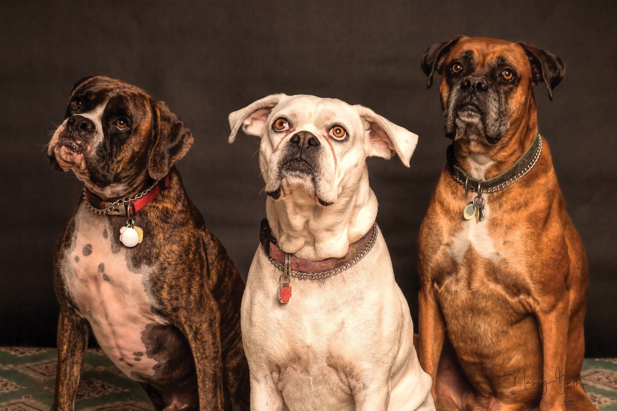

And here is an image of a baby duck

